Webpage Name- fintech financial services in India
Website: https://www.mudralaya.com/fintech- financial-services-in-India/
Fintech Financial Services in India | Fintech Investment in India Opportunities
India's Fintech Revolution: Where Innovation Meets Everyday Money
From street vendors accepting UPI QR codes to millions banking on phones, fintech financial services in India have rewritten how Indians handle money. What started as digital payments has exploded into lending, insurance, investments, wealth management, and more – making finance faster, cheaper, and inclusive for crores.
The Explosive Growth of Fintech Financial Services in India
India leads the world in digital payments thanks to UPI, with billions of transactions monthly transforming small shops, kirana stores, and even rural areas. Beyond payments:
- Digital lending platforms offer instant loans without paperwork
- Neo-banks and wallets provide seamless banking
- Insurtech delivers affordable health and life cover via apps
- Investment apps democratize mutual funds, stocks, and gold
- Wealthtech tools help manage portfolios with AI insights
This boom bridges urban-rural divides, empowers women and youth, and drives financial inclusion at scale. The sector is projected to reach massive revenues by 2030, fueled by smartphone penetration, Aadhaar, and supportive regulations.


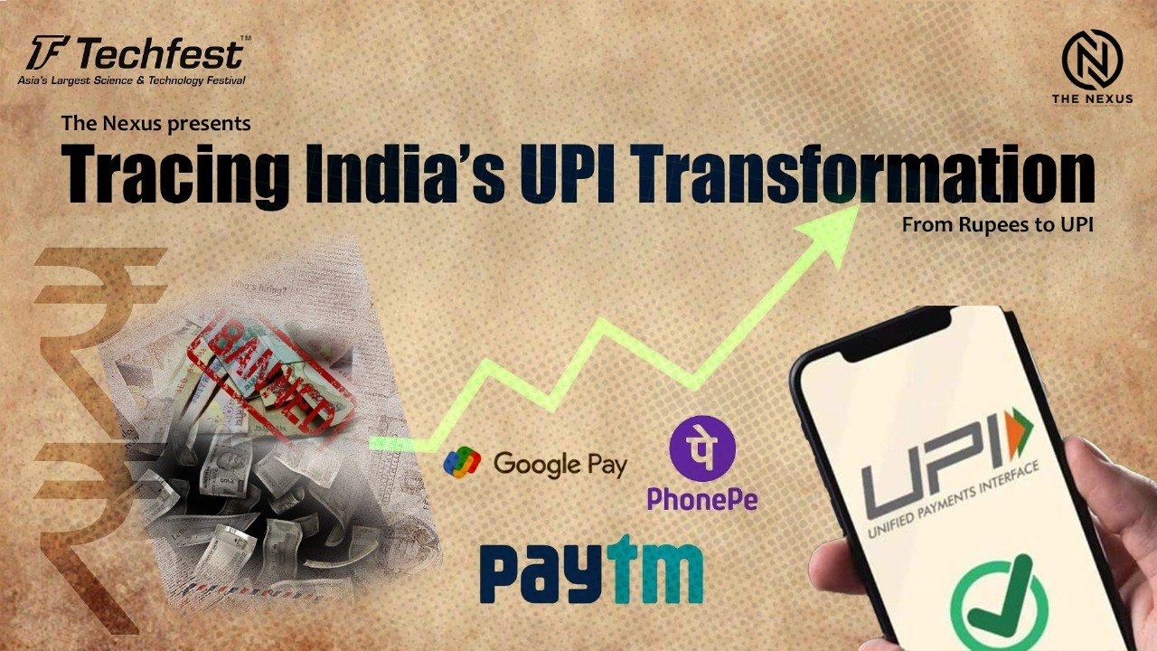
Why Fintech Investment in India Is One of the Hottest Opportunities
Investors are pouring in billions because:
- Massive untapped market: 1.4 billion people, many underbanked
- High growth trajectory: Strong recovery post-funding winter, with equity funding surging
- Proven unicorns: Multiple fintech giants valued in billions
- Regulatory tailwinds: RBI's sandbox, open banking initiatives
- Tech advantage: Low-cost innovation, AI/ML, blockchain integration
From seed to late-stage, opportunities abound in payments, lending, insurtech, wealthtech, and embedded finance. Early investors see high returns as startups scale nationally and globally.

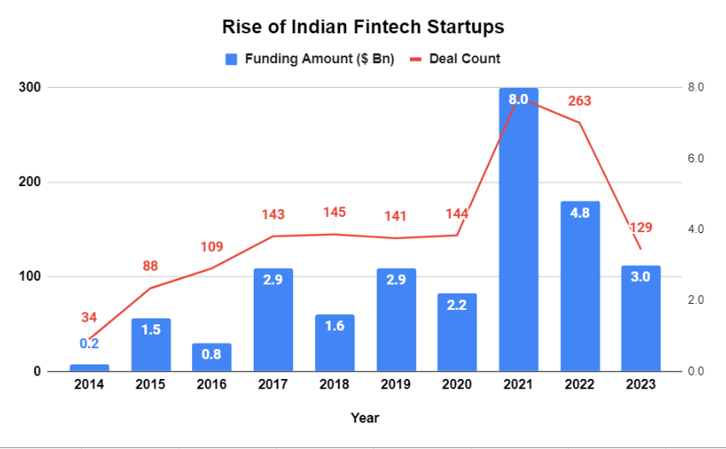
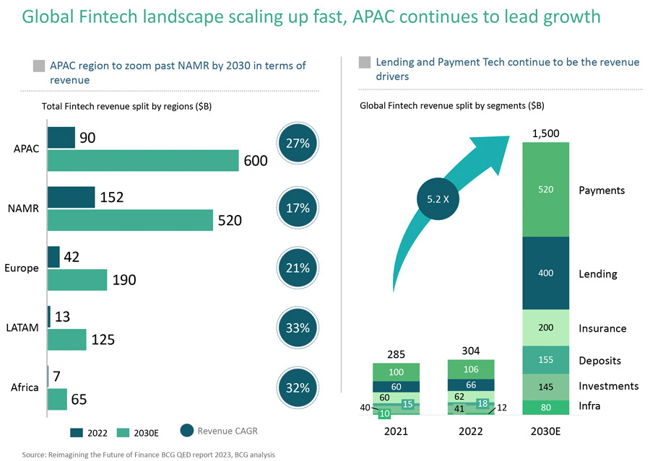
Key Areas Driving Fintech Investment in India
- Payments & UPI Ecosystem – Continued dominance and new features like UPI for feature phones
- Lending & Credit – MSME, personal, buy-now-pay-later models
- Wealth & Investment – Robo-advisors, fractional investing
- Insurtech – Micro-insurance, health tech bundles
- RegTech & Compliance – Tools for seamless KYC, fraud detection
With strong investor interest from global and domestic funds, the ecosystem is ripe for breakthroughs.
Join the Future of Finance in India
Fintech financial services in India aren't just disrupting banks – they're creating inclusive, efficient, and innovative financial access for everyone.

